Problem-1: Inheritance and Object Reference Manipulation in Java.

Code:

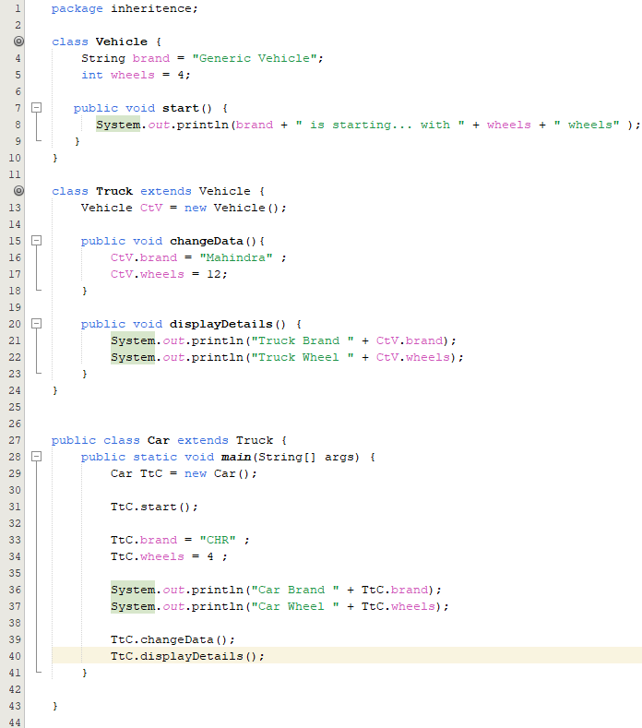

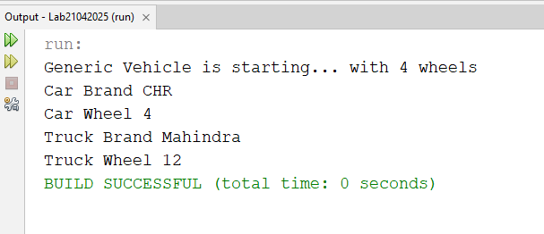

Problem-2: Accessing Members of Inner Classes in Java

Code:

